APPENDIX A: APPLICATION FOR FUNDING FORM

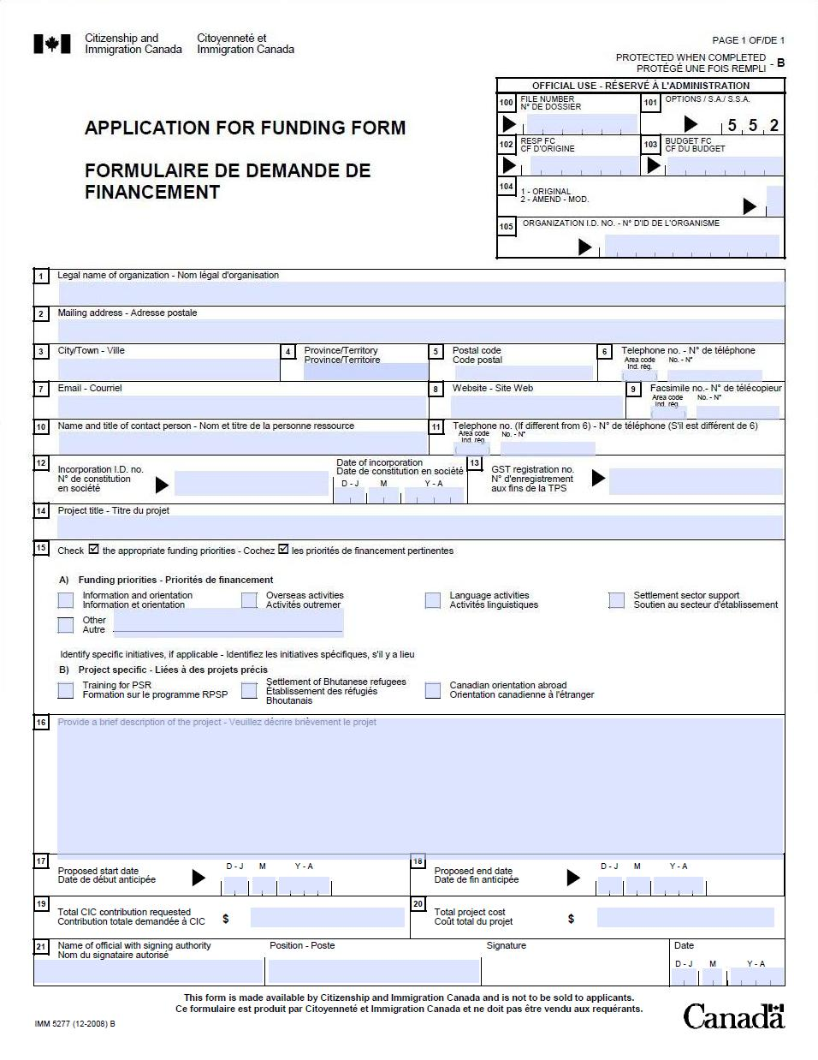
COMPLETING THE APPLICATION FOR FUNDING FORM (IMM5277B)

Read this guide thoroughly before completing the Application for Funding Form. CIC does not require an electronic copy of this application form; however, one completed and signed form must be included with the printed copies of the proposal that is sent to CIC. This form can either be (a) completed on-line, printed, and signed, or (b) a blank form can be printed, completed manually with black ink, and signed.
Boxes 1–6:
Enter the legal name, address and phone number of the organization.

Boxes 7-8:
Include, if available, email and website addresses.

Boxes 9-11:
Enter the name, (position) title, phone and fax numbers of a contact person.

Boxes 12 – 13:
Enter the incorporation and GST numbers of the organization, if applicable.

Box 14:
Project Title

Box 15:
A) Check the appropriate funding priorities.
B) Identify specific initiatives, if applicable

Box 16:
Provide a brief description of the project

Boxes 17-18:
Enter the proposed start and end dates of the activities. (The actual dates will be negotiated, if the proposal is approved for funding)

Boxes 19-20
Enter the total funding requested from CIC for this proposal as well as the total project cost.

Box 21:
Enter the name and position title of the official who has authority to sign on behalf of the organization. Have this individual review, sign and date the application, before submitting it to CIC. An unsigned application will be screened out of the CFP process.

APPENDIX B: BUDGET DETAIL SAMPLE FORM
A separate budget is required for each fiscal year identified in the proposal.
Example of required information for Budget submission (including examples of budget items and required details):
A- ADMINISTRATION
ADMINISTRATIVE WAGES
Item | Details |  | Estimated Costs | CIC Contribution Requested
Administrative Assistant | $?/hour x ? hours
Total Administrative Wages: |  |  | $0.00 | $0.00
BENEFITS
Mandatory Employment Related Costs(MERC)
Non-Mandatory Employment Related Costs
Total Benefits: |  |  | $0.00 | $0.00
OVERHEAD
Office Rent | $? Total @ % for project
 | Total Overhead: |  | $0.00 | $0.00
$0.00 | $0.00
Total Administration:

B- PROGRAM DELIVERY
PROGRAM DELIVERY WAGES
Item | Details |  | Estimated Costs | CIC Contribution Requested
Total Administrative Wages: |  |  | $0.00 | $0.00
BENEFITS
Mandatory Employment Related Costs(MERC)
Non-Mandatory Employment Related Costs
Total Benefits: |  |  | $0.00 | $0.00
OTHER PROGRAM DELIVERY
Travel |  | $?/ticket x ? tickets
Total Other Program Delivery: |  |  | $0.00 | $0.00
$0.00 | $0.00
Total Program Delivery:
C- CAPITAL COSTS
Total Capital Costs: |  |  | $0.00 | $0.00
D- GST | Total GST: |  | $0.00 | $0.00
TOTAL: |  |  | $0.00 | $0.00
COMPLETING THE BUDGET DETAIL SAMPLE FORM

A - ADMINISTRATION

Administration Wages: Indicate only those positions which are not directly involved in delivery of project activities, but which provide support services to the project. Examples would include executive/corporate oversight and administrative and financial functions. Include each position title along with details such as hourly wage, the number of hours per week and number of weeks involved in the project.

Benefits:

Mandatory Employment Related Costs (MERCs) - Enter the total amount of MERCs that relate to the administrative wages listed in the previous section. This would be the employer’s contribution to Canada Pension Plan and Employment Insurance, as well as for vacation pay, Workers’ Compensation and Health Tax, and any other item required by your province, territory or region. Provide a summary of this total in your proposal.

Non-Mandatory Employment Related Costs (Non-MERCs) - Enter the total amount of Non-MERCs that relate to the administrative wages listed in the previous section, if offered by the organization to its employees. Provide a summary of this amount in your proposal and include excerpts from human resource policies, as appropriate, to further explain these benefits.

Overhead:

Enter the various categories of costs which support program delivery but are not directly related to program activities. Group like items together. Phone, fax, internet, wireless costs associated with administrative activities can be grouped under Communications Costs; office space rental, utilities, maintenance can be grouped under Accommodation Costs; photocopier, fax, etc can be grouped under Office Equipment Rental; the purchase of various office equipment/furniture can be grouped under Purchase of Office Equipment/Furniture, consultant or contractor positions can be combined by the Administrative or Financial Function that they perform. Provide a breakdown of each grouping in your proposal.

B - PROGRAM DELIVERY

Program Delivery Wages: Indicate costs of only those employee positions which are directly involved in project activities. Include each position title along with details such as hourly wage, the number of hours per week and number of weeks involved in the project. A short description of the expected duties for each position should be included in the narrative portion of your proposal. In the budget template itself, the title of the position is sufficient.

Note: The cost of consultants or other contractors should be indicated in the “Other Program Delivery” section as they are not employees of the organization.

A short description of the expected statement of work for consultative/contractual positions must be included in the narrative portion of your proposal. In the budget template itself, a descriptor for the consultant or contractor will be sufficient (e.g. accountant, auditor, media consultant are examples). (See Section C – Frequently Asked Questions, Q18 for additional information).

Benefits:

Mandatory Employment Related Costs (MERCs) - Enter the total amount of MERCs that relate to the Program Delivery Wages listed in the previous section. This would be the employer’s contribution to Canada Pension Plan and Employment Insurance, as well as for vacation pay, Workers’ Compensation and Health Tax, and any other item required by your province. Provide a summary of this total in your proposal.
Non-Mandatory Employment Related Costs (Non-MERCs) - Enter the total amount of Non-MERCs that relate to Program Delivery Wages listed in the previous section, if offered by the organization to its employees. Provide a summary of this amount in your proposal and include excerpts from human resource policies, as appropriate, to further explain these benefits.

Other Program Delivery:

Enter the various categories of costs which are directly related to program delivery activities. Group similar items together: e.g. phone, fax, internet, wireless costs associated with Program Delivery activities can be grouped under Communications Costs; office space rental, utilities, maintenance can be grouped under Accommodation costs. A number of consultant or contractor positions could be combined by the Program Delivery Function that they perform. The Program Delivery Costs associated with different sub-projects can be grouped within this section. Provide a breakdown of each grouping in your proposal. Purchase of software directly related to the project should also be listed.

C- CAPITAL COSTS:
Enter items or groups of similar items of $1000 or more. The total cannot exceed 15% of the value of the agreement.

D- GST:
Enter the amount of GST forecasted to be paid on purchases related to the project less expected rebate from the Canada Revenue Agency.

Eligible Expenditures

Reimbursement may be made toward project-related costs associated with the project as follows:
- Salaries, wages and related benefits;
- Training and professional development for employees and volunteers;
- Travel and accommodation costs for project staff;
- Overhead costs including rental of space or equipment and costs associated with administration and audit;
- Professional or consultancy fees for technical and legal advice, accounting and audit services (see the Frequently Asked in section C – Question 16 regarding contracting guidelines);
- Capital expenditures (at the discretion of the department) including costs for arrangements and devices for eligible clients with disabilities of up to $10,000 per client to a maximum of $100,000 per year per agreement;
- Materials and supplies directly related to the success of the project;
- Research, conferences, workshops and publicity/project marketing costs, such as promotional materials, advertising, websites;
- Costs related to printing, translating and dissemination of materials and documents that will be distributed to the public as an official document or to other service providers/organizations that will use this material to provide services or information. (The Settlement Program takes into consideration Canada’s commitment to official languages duality.)

What Is Not Reimbursed

- Expenses related to rewards and recognition. It may, however, be permissible, with the approval of the Department, to use non-salary funds for small expenditures, such as plaques.

CIC will not reimburse costs incurred abroad or related to activities outside Canada, including costs related to international travel except for those projects that have clearly identified an overseas component and the necessity of the international travel;

Salaries, benefits and travel costs for elected principal officers such as directors, executive officers and members of managing committees; (these are not eligible for funding without the explicit permission of CIC);

Costs associated with validation of individuals’ credentials;

Activities that have already been undertaken or completed before an application is made or before an approved contribution agreement is in place;

Expenditures related to profit-making activities.

APPENDIX C: FREQUENTLY ASKED QUESTIONS
Please be aware that all information necessary for the completion of a proposal is included in the “Guide for Applicants”. This CFP pertains strictly to settlement project funding – for any general questions concerning immigration matters please consult CIC’s website: www.cic.gc.ca.

Q1: What is the deadline for the submission of proposals; must CIC have received the proposal by this date or is post-marked sufficient?
A1: The deadline for the submission of proposals is February , 2012. All mailed proposals must be post-marked by this date. If hand-delivered, proposals must arrive at the Department by 16:00.

Q2: Is an extension on the deadline for submissions possible?
A2: No. To support fairness in processing, any proposals received after the deadline will not be considered and will be screened out.

Q3: How much funding is available; what is a reasonable amount for a project budget?
A3: That will depend solely on your proposed activities and project scope. It is important to remember however, that value for money and cost-effectiveness will be reviewed in the assessment phase.

Q4: Will there be an opportunity to speak with departmental representatives in order to ask questions concerning the CFP?
A4: No - staff cannot assist organizations in the development of their original proposals.

Q5. Why is there such a big emphasis on expected results in this Call for Proposals?
A5. Results measurement shifts the focus from activities to results, from how a program operates to the benefits and impact it accomplishes. CIC has focused on expected results in its modernization of the Settlement Program. Asking each proposal author to specify, measure and report on expected outputs and results for their project will, in turn, provide CIC with information that will help the department determine overall impact of settlement programming on newcomers and to help identify best practices and areas for further investment and development.

Q6. What is an in-kind contribution?
A6. Expertise, services or facilities are some examples of in-kind contributions. You or your partners may offer administrative or managerial services, facilities or access to equipment. You or your partners may also lend staff to work on the project while remaining on your or their payroll. If no money is exchanged for the service or resource, it is considered an in-kind contribution. Your organization or a partner’s organization may also make cash contributions to cover project eligible costs. Your proposal must describe how the in-kind contributions or cash contributions from other sources will be tracked if they are made available.

Q7. How long will it take for my proposal to be assessed for possible funding?
A7. Proposals are subject to a thorough review and assessment process by departmental staff, a review committee, subject-matter experts where appropriate and other departmental officials. Given this assessment process, accurate timelines cannot be provided at this stage since the number of proposals that will be received is unknown before the launch of the call.

Q8. We are considering hiring a consultant/contractor. Do we consider these consultants as employees?
A8. No. Consultants and contractors are deemed to be independent workers and are not paid additional benefits above their standard fee, nor are they to be considered employees. These individuals are not subject to the normal benefits and considerations of employees of the project or of the organization. The statement of work they provide should cover details such as the fee structure, hours/days of work, statutory holiday situations, the start and end of the contractual period along with a full description of the expected work with milestones and progress reporting periods. For further information on what constitutes an employer-employee relationship, please consult with your provincial Department of Labour representative and the Canada Revenue Agency.

