**Pathways to Prosperity 2023 Virtual Workshop Series**

**Instructions: Workshop Speakers and Chairs**

**Workshop Time**

* As a workshop chair/speaker, you are requested to **join the workshop 45 minutes before the official start time**, so we can go through the logistics and technical questions that you may have
* The workshop is scheduled for **75 minutes** (1 hour and 15 minutes). Workshops **begin at 1:00PM EST**
* We request that the total presentation time be a maximum of **60 minutes, leaving at least 15 minutes for Q&A**

**Preparing your PowerPoint**

* Workshops chairs are responsible for collecting all PowerPoints for their session beforehand and **emailing these at least two days before your scheduled workshop. Please email the PowerPoint decks to workshops@p2pcanada.ca** We will then upload your PowerPoints onto the virtual conference platform.
* **Note: You will still be required to share your screens/presentations during the LIVE event in order to show your PowerPoint to the audience. The presentations you are sending us are for publishing on the conference website only.**
* The PowerPoints should be designed in wide format (16:9). We request that you use large text size on your slides. Do not add too much information on a single slide.

**LIVE Presentation: Panelists Meet on Zoom For the LIVE Workshop**

For your upcoming workshop presentation, we will send you a Zoom Webinar Invite, which will look similar to the screenshot below:

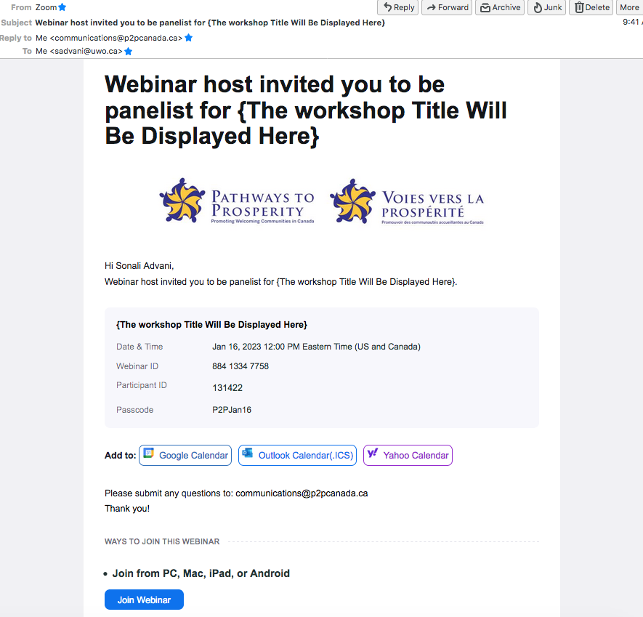

Please sign in to this zoom link **45 minutes** before your LIVE presentation.

On the day of the event, we will do pre-checks before your live presentation (check webcam, lighting, microphone), and we will remind you how to share your screen.

**Important to Note:**

**PLEASE DO NOT SIGN INTO OUR VIRTUAL CONFERENCE PLATFORM (Pheedloop) during your live presentation. YOU SHOULD ONLY BE LOGGED INTO THE ZOOM MEETING.** The attendees will watch your live presentation on our virtual platform, but there may be a 10 second lag between the zoom meeting room you are in and the video that is broadcast on Pheedloop. Thus, we ask you to please NOT OPEN the virtual platform (Pheedloop) during your live session. You should focus on the zoom meeting room.

**Workshop Format**

* The workshop is being held as a ‘webinar’.
* Audience members will interact with you via text-based questions and can respond to audience polls you have set up with us beforehand.
* You will be able to view a list of attendees, but you are not able to see or hear them.

**Sharing Your Presentation/Screen:**

* During the live presentation, you are required to share your PowerPoint presentation. To do so, please use the “Share Screen” option within the Zoom window. You will then advance the slides as needed.
* During the workshop presentation, each presenter can share their screen and show individual presentations. Alternatively, you can appoint one person from your panel to share all presentations. This will need to have been decided in advance and you would then give the appointed person your PowerPoint presentations. In this case, this appointed person should follow your spoken word and advance the slides as needed. You can choose to give a verbal cue (e.g. next slide) to the appointed person.
* If you are playing a video, please make sure that you check the “Share Sound” option when sharing your screen (see image below). Do not mute yourself when playing a video.

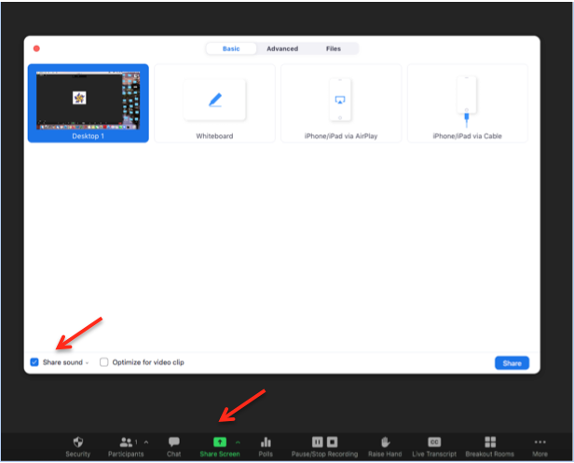

**Handling of Audience Questions**

* Audience members will use Zoom’s integrated Q&A system to submit questions.
* The questions will show up in your Zoom meeting room. Please click the Q&A button at the bottom of your Zoom window. The questions will appear in a pop-up window.
* Participants can upvote questions. You will thus be able to see which questions are most popular and may want to answer those first.

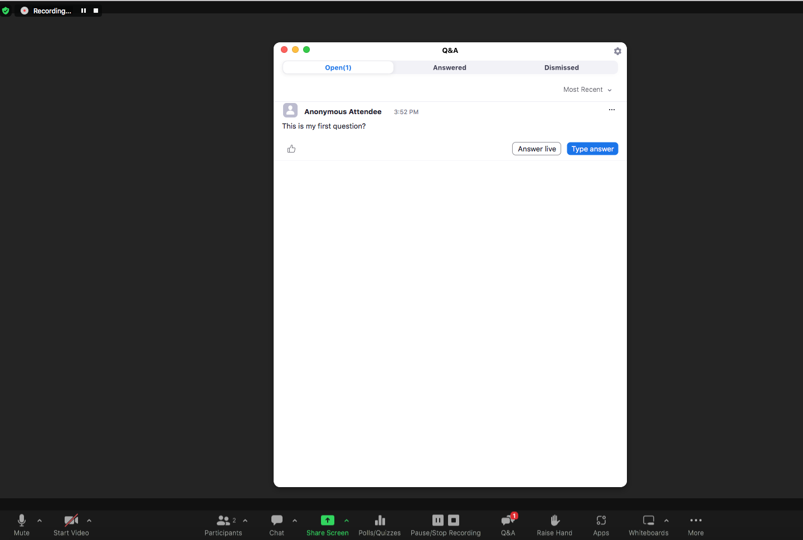

* Workshop chairs are requested to choose the questions you think are most important to address, and try to direct them to a particular person on the panel. Chairs are requested to use Google translate, if needed, to understand and ask the question in your preferred language.
* You are requested to respond to as many questions as possible, LIVE during the webinar. You can also send a text-based response by using the “Type Answer” option.

**Audience Poll**

* If you wish to use audience polls, please email us the poll questions along with options at least 3 days before your live event.
* A P2P representative will be present on Zoom, and will initiate the audience poll. Please give a verbal cue to the P2P representative when you want the poll to be initiated.
* You will be able to see the poll results in realtime.

**Zoom Chat Function**

* Since the attendees are watching the live broadcast on our virtual platform, they do not have access to the zoom chat function.
* Panelists can use the chat box to communicate with other panelists and with P2P (Host).

**Housekeeping guidelines**

* You can choose to ‘mute’ your audio when you are not speaking. Do remember to ‘unmute’ yourself when you are presenting
* Switch off all notifications on your computer (eg. Email notifications, news etc)
* Switch off your cell phones
* Make sure you are not seated close to your home/office landline phones, or they are kept on silent, or off the hook
* **Close all computer applications, except your PowerPoint presentation, and the Zoom meeting you are logged into**
* **DO NOT log into the P2P 2023 Workshop Series platform (Pheedloop)**
* If possible, ask your family members to not use the home internet for the purpose of streaming and gaming when you are doing your LIVE workshop. This will ensure you have a good level of bandwidth
* Try to minimize distractions at home and office, making sure your colleagues and family are aware not to disturb you

**Emergency Numbers**

* In case of emergency and for technical issues, please contact Sonali Advani at   
  519-702-6273 before the LIVE presentation